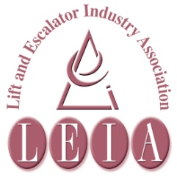
S

The Lift & Escalator Industry Association
SAFETY Matters
July 2016

Tel: 020 7935 3013
Fax: 020 7935 3321
Email: enquiries@leia.co.uk

Introduction
Welcome to the July 2015 edition of Safety Matters.
Through this newsletter our aim is to inform you of health and safety issues that may have an impact on the lift and escalator industry. Safety Matters is also available for download from the LEIA member’s website. www.leia.co.uk

Contents
- Breathe Freely
- Violence at Work
- Lepto-spirosis
- Mobile Phones and Driving
- Liam loves Lifts

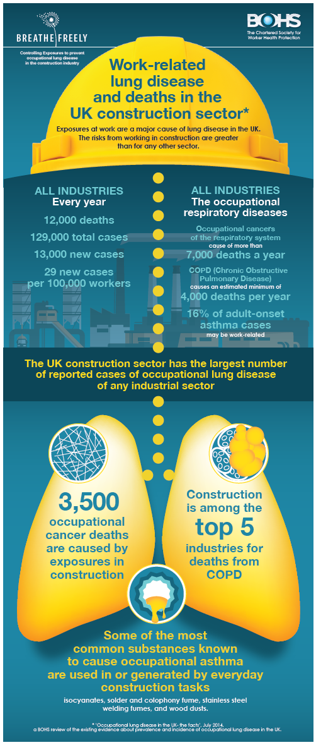

Breathe Freely Campaign
The British Occupational Health Society (BOHS) in collaboration with the HSE and others are running a campaign to highlight and prevent occupational lung disease in have started in the construction industry.
As BOHS say:
We have to start somewhere and the facts about this sector are particularly shocking.
There were 42 fatal injuries to UK construction workers in 2013/14. Each of these is an individual tragedy. But in the same industry and over the same period of time (a year), there were about 5,500 new occupational cancer cases, 5,000 deaths from asbestos and 500 deaths from exposure to silica dust alone. That’s a considerably bigger tragedy
The poster opposite summarises the problem.
Those of you working in construction may find more attention and emphasis on control of dust, and maybe fumes, generated by your work.
Any controls which your employer puts in place - such as using a vacuum cleaner in preference to sweeping or use of protective equipment like disposable respirators (dust masks) – must be used.

The HSE definition of work‐related violence is:
VIOLENCE AT WORK
'Any incident in which a person is abused, threatened or assaulted in circumstances relating to their work'.
Verbal abuse and threats are the most common types of incident. Physical attacks are comparatively rare. Most employers will adopt a zero tolerance to this behaviour.
RISK ASSESSMENT
An incident of violence is most likely to affect field based employees attending calls alone in unsupervised or Public Buildings/Areas at night, but could occur anywhere at any time.
Employees should be on the lookout for signs of trouble at all times.
WARNING SIGNS
• Mild verbal abuse which gets worse
• Irrational behaviour
• Drunkenness/ Suspected drug abuse
ACTION
If in the course of work an employee perceives, or suspects, there is the threat of violence from any person then they should leave the immediate vicinity and return to a place of safety. If necessary the aggressor can be told another tool or piece of equipment is required to do the job.
They should then leave the site with the job made safe but uncompleted.
If persons are left trapped in a lift then the originator of the call must be contacted by phone and directed to the emergency services.
FURTHER MEASURES
Should instances of violence be known to occur at particular locations then the measures that are to be considered by Management include:
• Withdrawal of Lifts from service, by client, at high risk times to eliminate the need for attendance
• The prohibition of calls at times when the problem exists (e.g. not attending night calls).
• Provision, by the client, of adequate trained security and supervision in building at times work is undertaken
• Cancellation of contract
• Deployment of two or more people (in most situations this is unlikely to prove an adequate measure)
VICTIMS OF VIOLENCE
Support
In the event an employee is the victim of violence in the course of their work then it is recommended that appropriate support including counselling be provided.
Reporting
The police should be notified of any instance of violence. Additionally any instance of violence must be reported in accordance with your own company accident reporting procedures and recorded. This will enable review of procedures and revising or implementing any of the above measures.
It should be noted that “physical violence done to a person at work” is within the definition of an accident within RIDDOR (Reporting of Injuries, Diseases and Dangerous Occurrences Regulations 1995) and where this results in either an over 7 day absence, a major injury or even death then the incident must also be reported to the enforcing authorities in addition to the police.
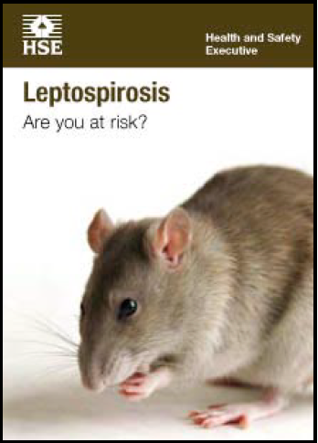
This is a nasty disease that can affect workers in construction particularly building refurbishment and demolition. In our work, generally, we have always considered this risk of this disease to be low. However, there is always the possiblility of contracting this if working in a rat infested area.
LEPTOSPIROSIS
The Weil’s disease form of Leptospirosis is contracted from the urine of infected rats. The bacteria get into your body through cuts and scratches or through the lining of the mouth, throat and eyes after contact with infected urine or contaminated water.
It is a rare condition in the UK.
The disease starts with flu-like symptoms such as a headache or muscle pains. More severe cases can lead to meningitis, kidney failure and other serious conditions and in rare cases the disease can be fatal.
The disease is linked to areas where rats are or have been present and there could possibly be rats in areas where we work.
HOW TO PROTECT YOURSELF
- Wearing protective clothing like gloves.
- Following good basic hygiene including regular hand-washing and avoiding hand to mouth/eye etc contact.
- Taking rest breaks, including meals and drinks, away from the work area;
- Washing cuts and grazes immediately with soap and running water Cover all cuts, abrasions and other breaks in the skin with waterproof dressings and/or gloves.
MOBILE PHONES AND DRIVING
Mobile phones—a sad cautionary story
A driver using his mobile phone who crashed into the back of a car, killing a woman, has been jailed.
Robert Munce, 47, was travelling along the A1 near Newark, Nottinghamshire, in November 2014 when he failed to see traffic was slowing down. He hit Margaret Nile's car at 60mph, killing the 65-year-old and causing a series of other crashes.
At Nottingham Crown Court Munce admitted causing death by dangerous driving and was given four years. He was also banned from driving for seven years.
Please take a few minutes to refresh your memory on your own company’s rules for using mobile phones in cars and vans.
Even if using a hands free kit, it can be very distracting; If someone phones you, tell them you’re driving and will ring back.
The case above a very sad and extreme case but for a driver to get into trouble they only have to be caught using the phone. You can be sure any mobile phone in a vehicle involved in a serious accident will be part of the evidence the police will look at.
The extract below is from https://www.gov.uk/using-mobile-phones-when-driving-the-law
It’s illegal to ride a motorcycle or drive using hand-held phones or similar devices.
The rules are the same if you’re stopped at traffic lights, queuing in traffic or even parked up safely but with the engine running.
It’s also illegal to use a hand-held phone or similar device when supervising a learner driver or rider.
You can get an automatic fixed penalty notice if you’re caught using a hand-held phone while driving or riding. You’ll get 3 penalty points on your licence and a fine of £100.
Your case could also go to court and you could be disqualified from driving or riding and get a maximum fine of £1,000. Drivers of buses or goods vehicles could get a maximum fine of £2,500.
New drivers: you can lose your licence if you get 6 or more penalty points within 2 years of passing your test.
Little Fingers Campaign
LIAM LOVES LIFTS
In the LEIA 2015 Accident Statistics report there were many of children putting their hands on lift doors as the car is arriving (especially glass doors) and watching the car as it arrives. The children tend to keep their hands on the doors as they are opening, causing their fingers to be drawn in between the architrave and the door.
Looking at the historical accident reports identified many more such incidents and LEIA Safety and Environment Committee thought it appropriate that we spread this safety message to those most able to control the hazard – parents and guardians.
Liam (who loves lifts) was introduced at LiftEx on 25th and 26th May. He was an immediate success, with the book and height chart displays constantly being refilled on the LEIA stand. You are invited to contact LEIA and order copies of Liam’s book and height chart, free of charge, and to circulate them widely.
Liam Loves Lifts was design to be attractive to children and to start the conversation and this was how the campaign was designed; it’s been put on Facebook, Mumsnet, LinkedIn, Twitter so that it starts an online conversation.
The books and height chart can be requested from LEIA directly or through the website www.liamloveslifts.com
